**NM PROJECT**

**HOW TO CREATE A LANDING PAGE IN HUBSPOT**

STEP 1:Search “hubspot landing pages in google”.

STEP 2: In Hubspot Websites select free CMD.

STEP 3: Sign in with your email id & after sign in they create an account.

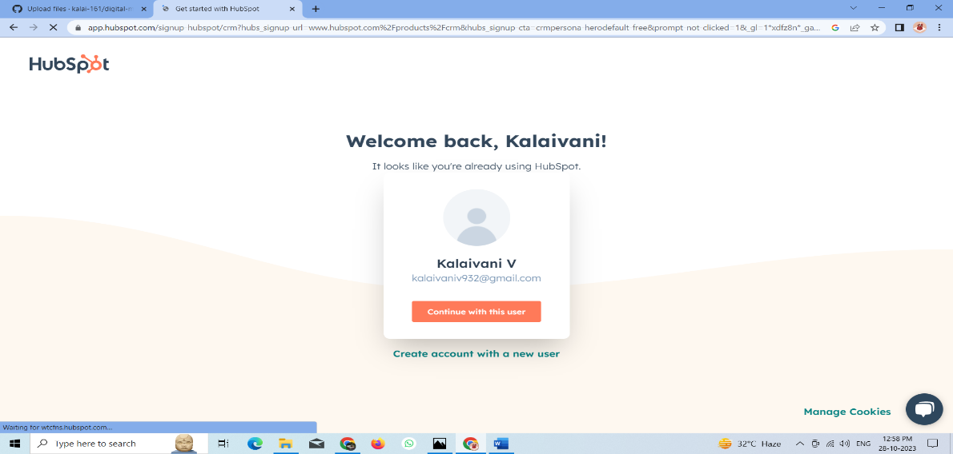

STEP 4: Go to above option and select marketing option and select a landing page option

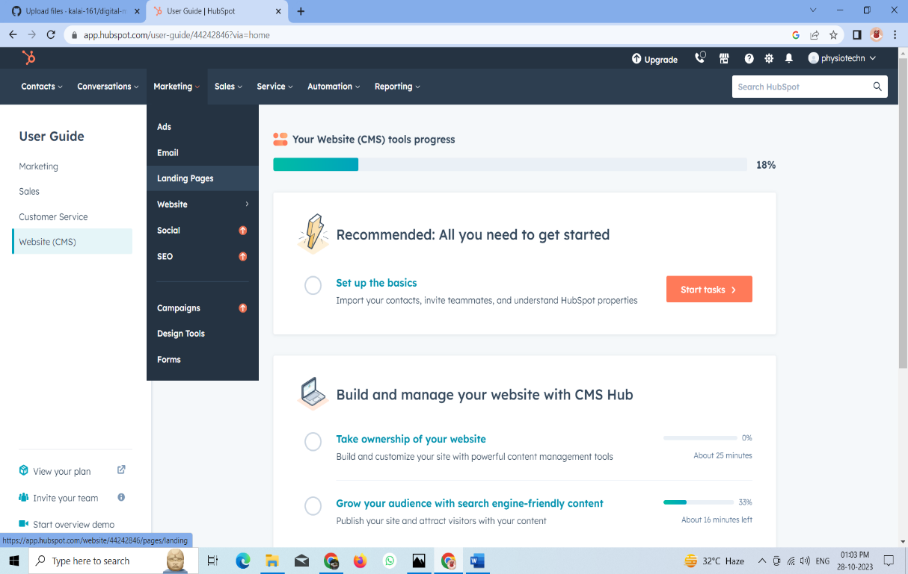

STEP 5: Select the get started button.

STEP 6: Add the websites as physiotechn.com.

STEP 7:Add Templates and logo & Content required completed.



Logo for project.

STEP 8: Select new form.

STEP 9: Create page name as source and remove a slug from a customized template.

STEP10: After all instructions & Publish.

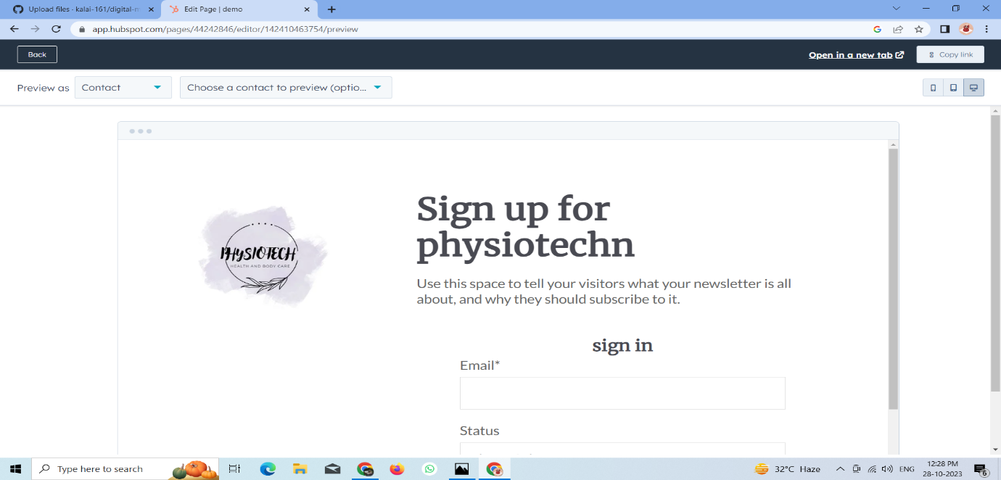

After the published..